**PRODUCT REVIEW OF TIFFANY & CO. SHADES**

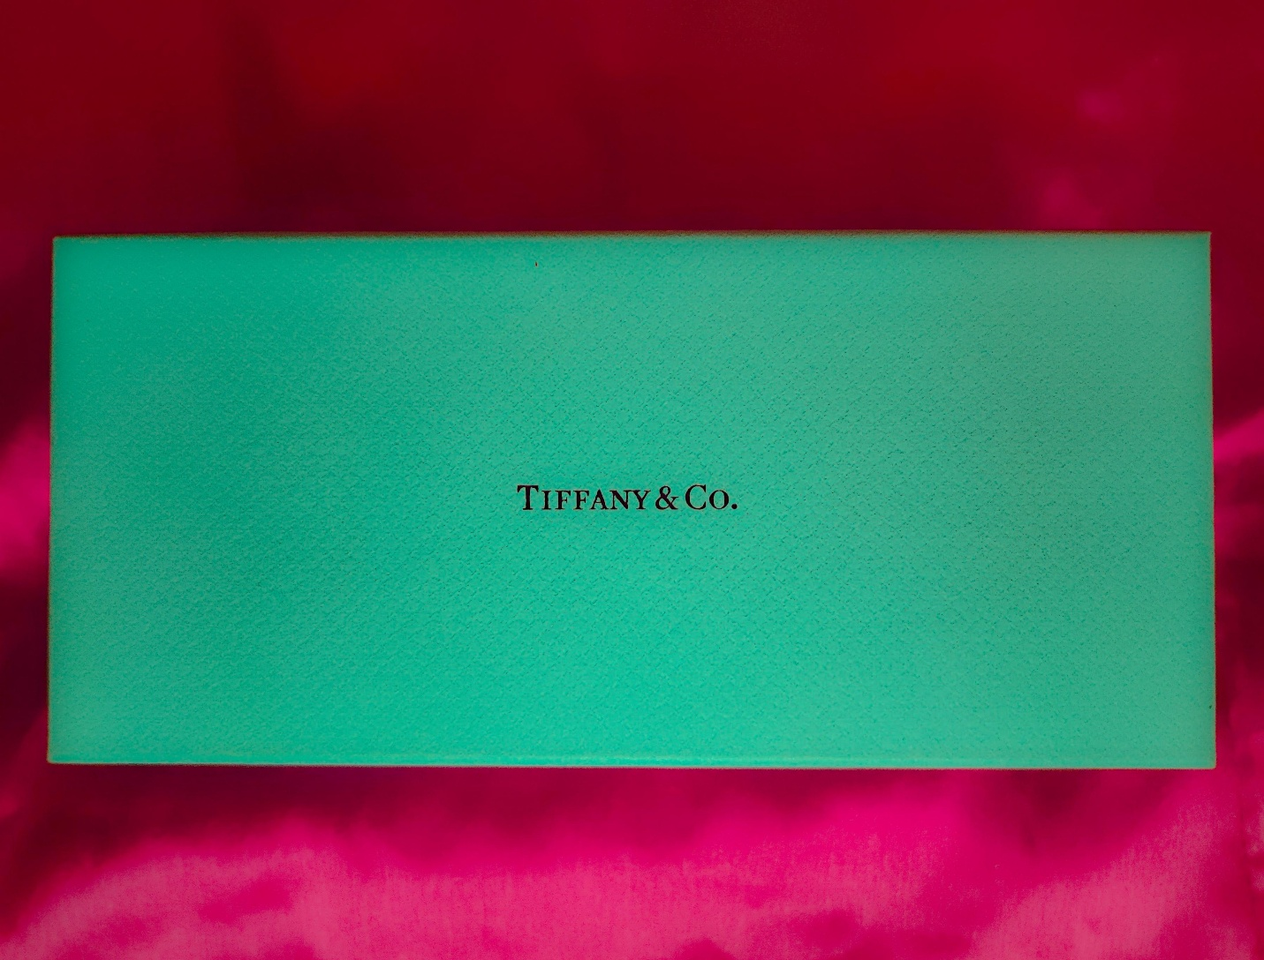

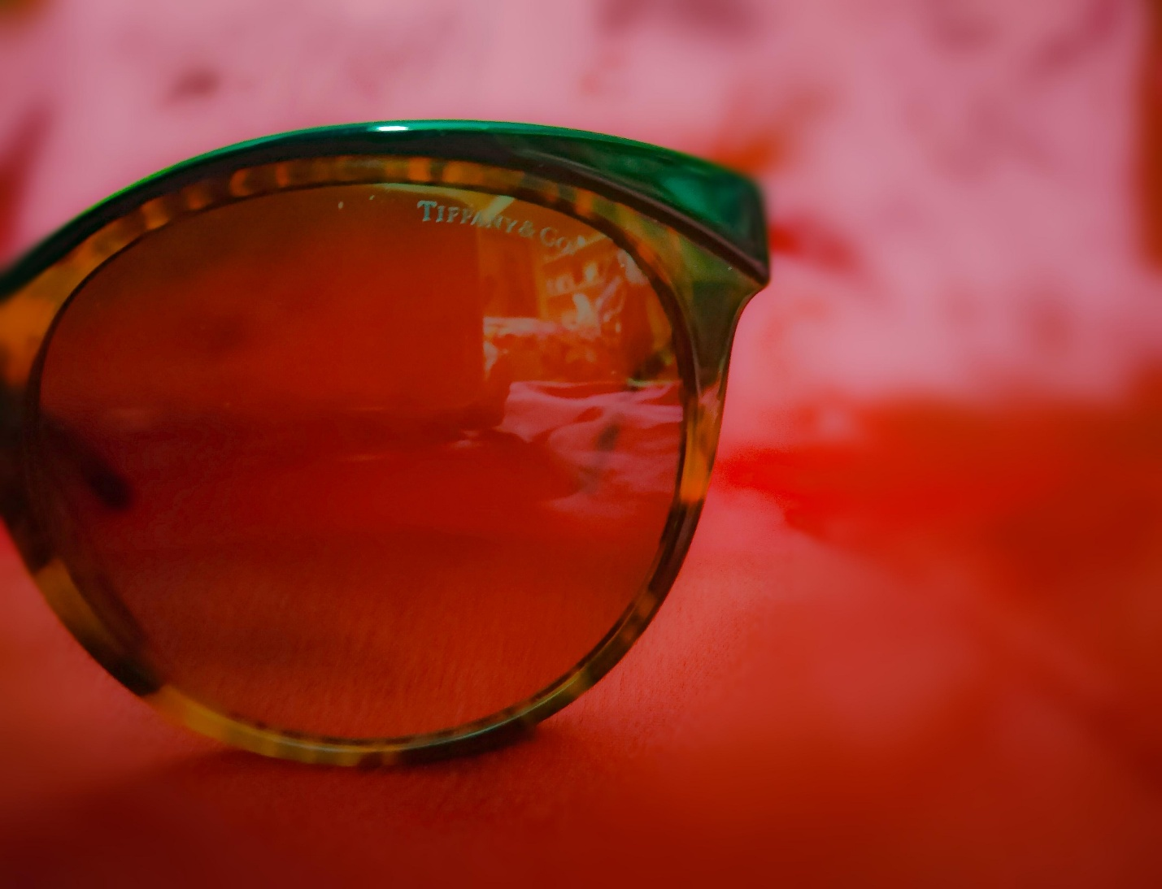

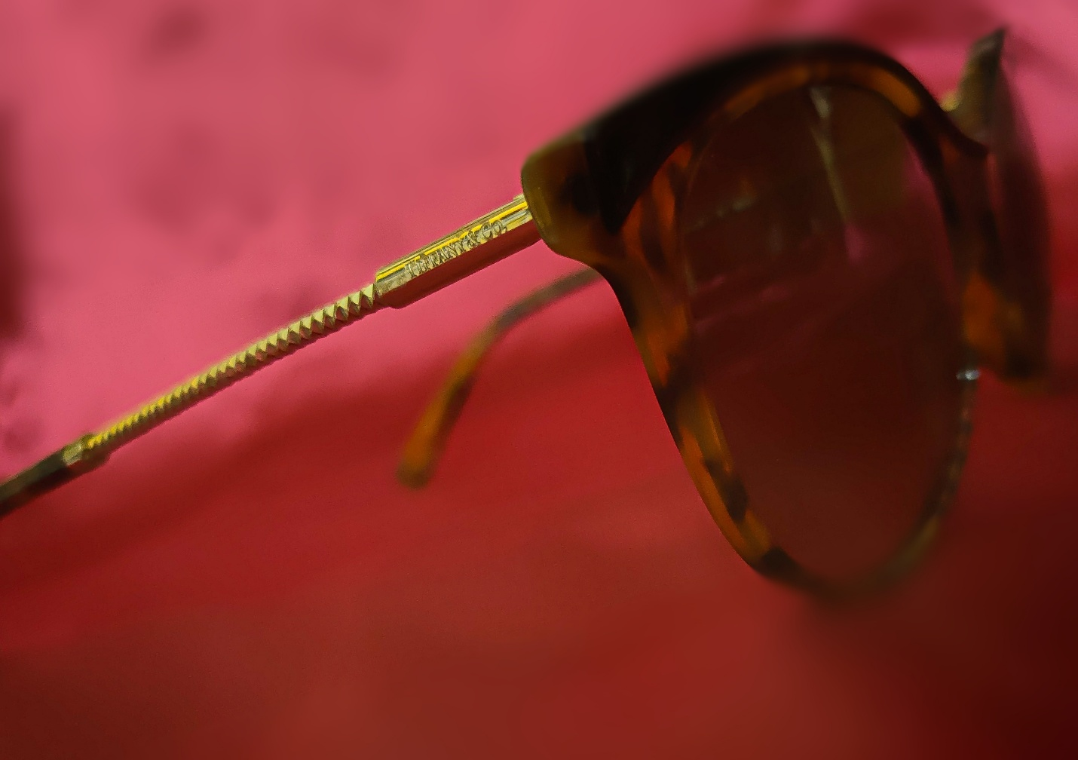

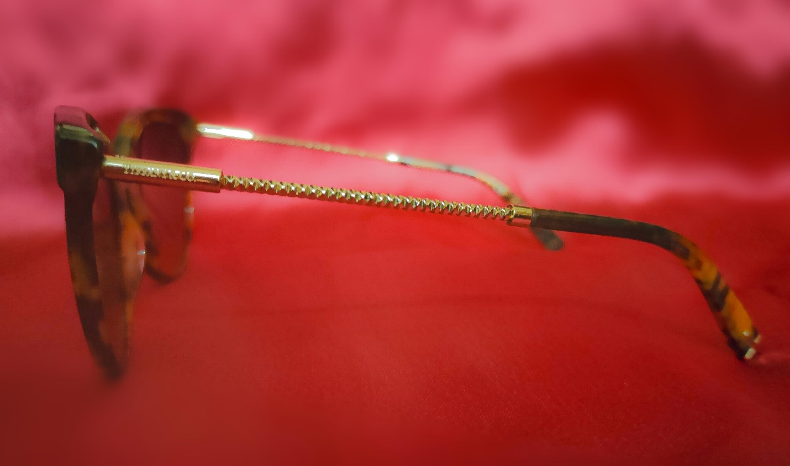

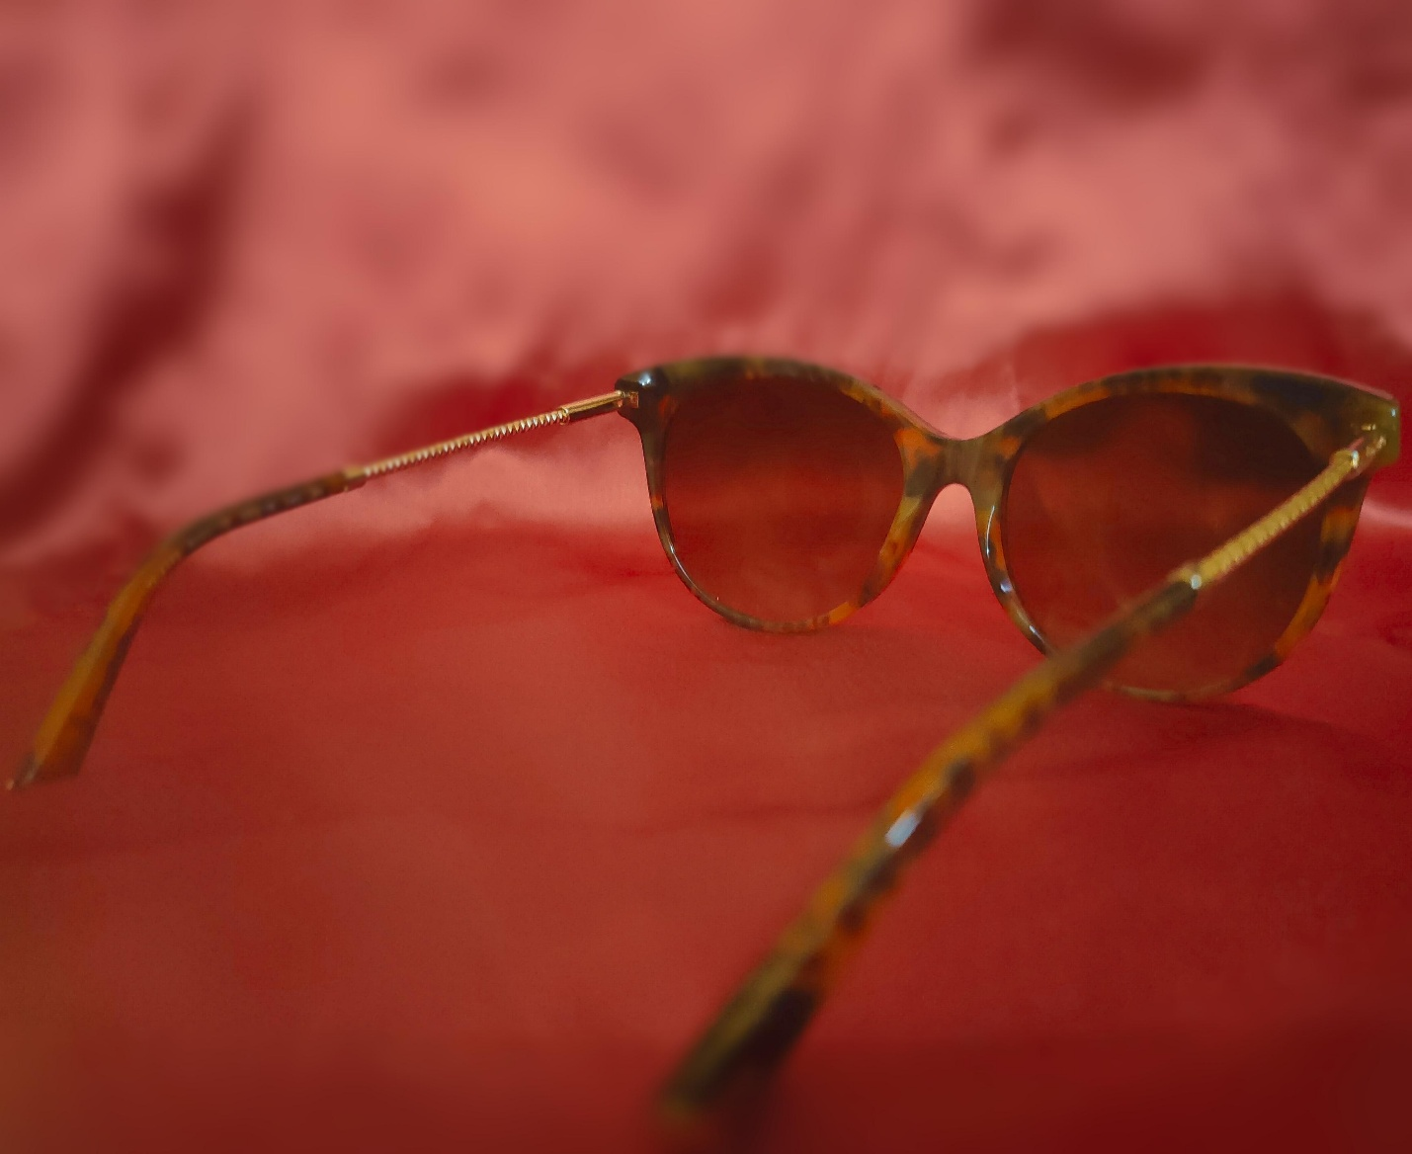

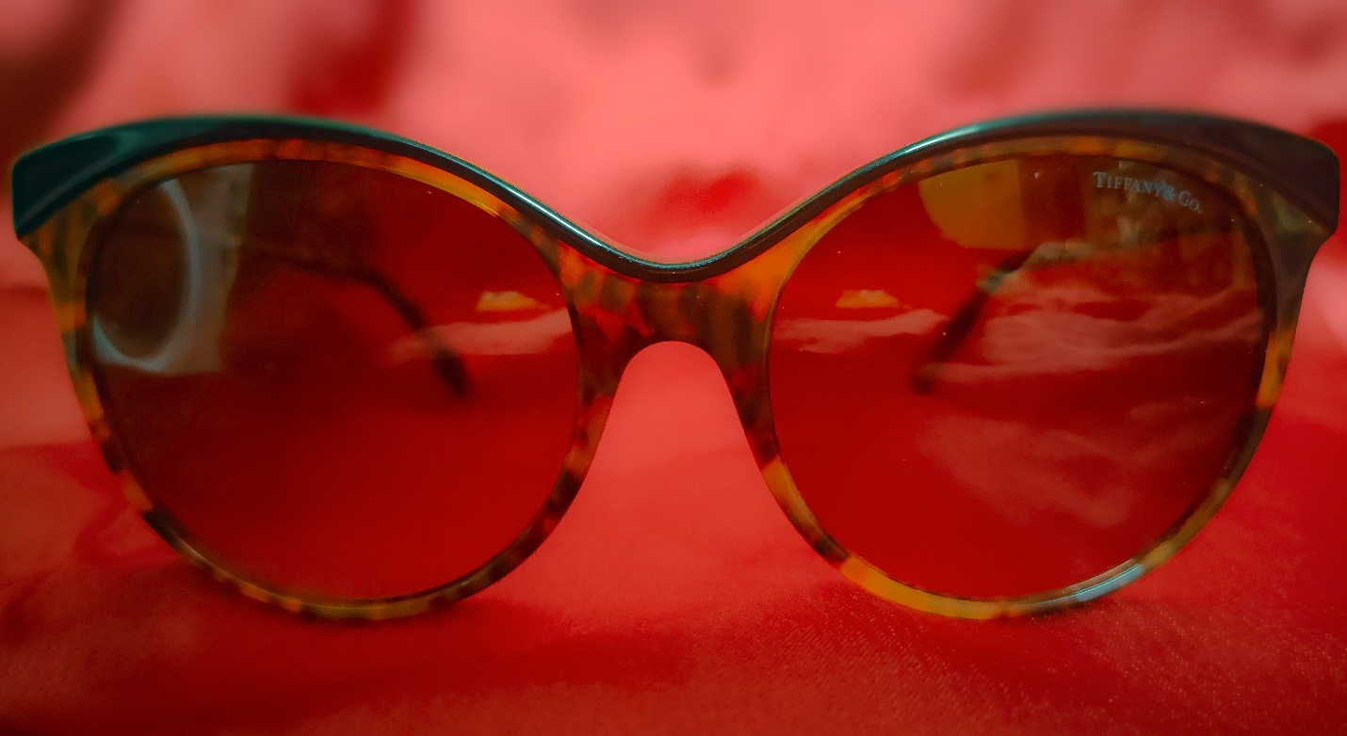

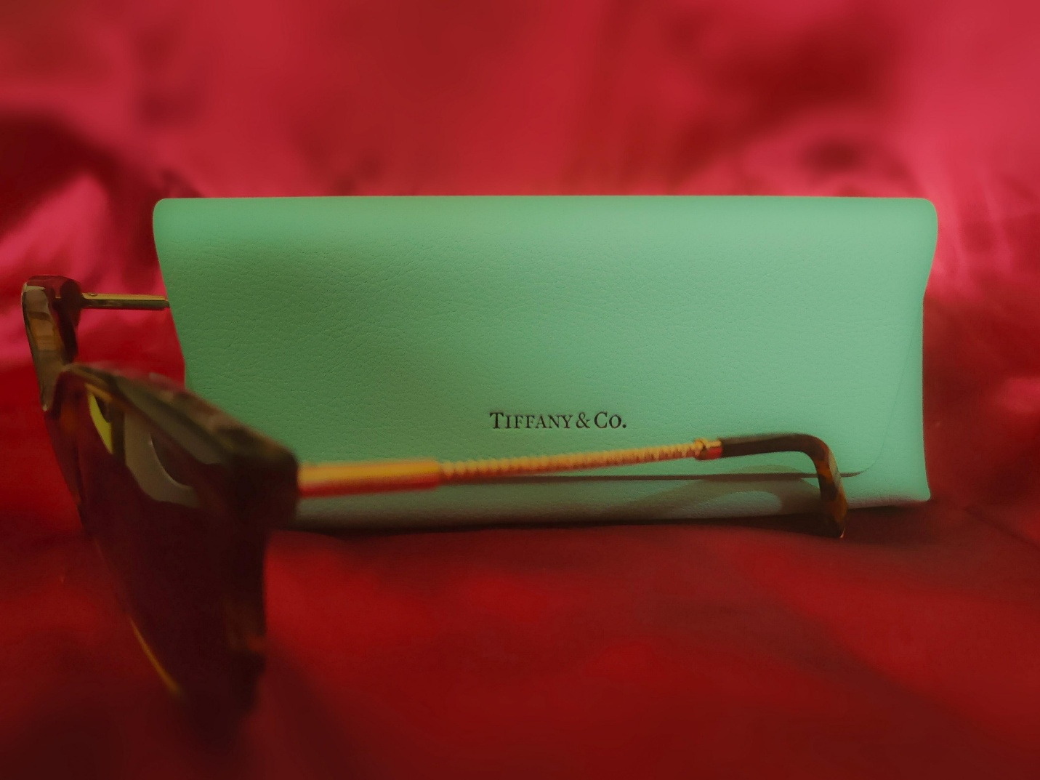

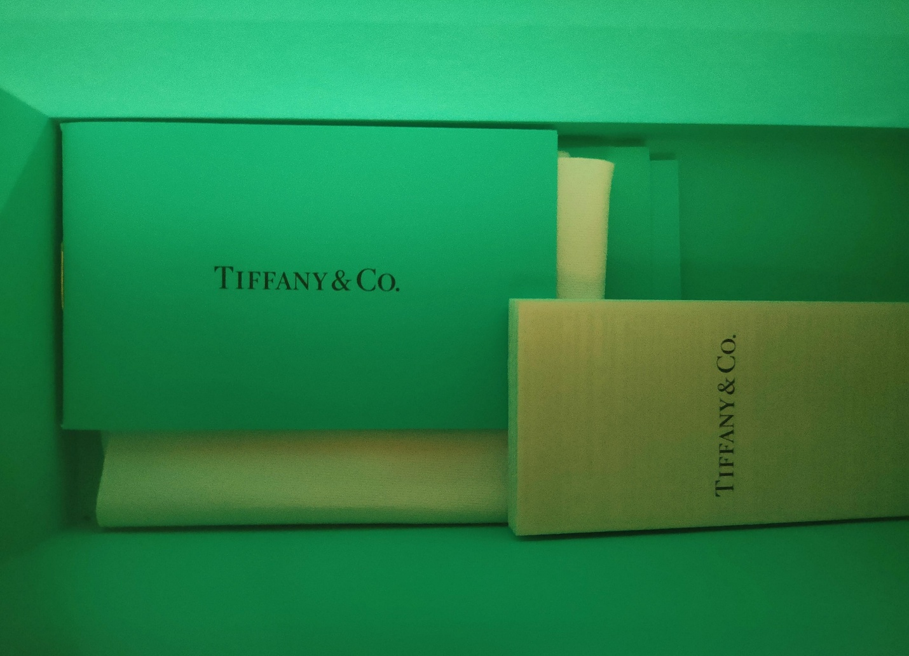

Tiffany & Co., a legendary brand established in 1837, is synonymous with luxury and sophistication. Known for its exquisite jewellery and accessories, the iconic Tiffany Blue Box has become a symbol of prestige and unparalleled craftsmanship.

These Tiffany & Co. shades exemplify the brand's commitment to excellence. The frames are a testament to meticulous craftsmanship, showcasing both durability and aesthetic appeal. The signature Tiffany Blue tint on the lenses adds a touch of distinctive elegance, instantly recognisable and synonymous with the brand's timeless style.

Beyond the stylish aesthetics, the functionality of the shades is impressive. The lenses not only provide excellent clarity but also offer superior UV protection. The attention to detail, from the precision of the hinges to the flawless finish, reflects the brand's dedication to creating accessories that transcend trends and stand the test of time.

While Tiffany & Co. shades may come with a premium price tag, the investment is justified by the enduring quality and the prestige associated with the brand. Wearing these shades is not just about shielding your eyes from the sun; it's about making a statement, a declaration of refined taste and an appreciation for the artistry and heritage that Tiffany & Co. represents. In the world of luxury eyewear, these shades stand as a true embodiment of timeless elegance.